Physics 30 1995 January

- 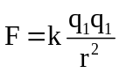 is an expression of the law attributed to
A. Ohm
B. Newton
C. Coulomb
D. Kirchoff

- An initially uncharged ebonite (hard rubber) rod is rubbed with an initially uncharged piece of cat's fur. As a result, the fur becomes positively charged and the ebonite becomes equally charged negative. This best illustrates
A. the law of conservation of charge
B. the law of conservation of mass
C. Coulomb's law
D. Ohm's law

Use the following information to answer the next question.

Factors Related to Point Charges

I the magnitude of the charge
II the sign of the charge
III the distance from the charge
IV the magnitude of the test charge

- Which factors are needed to determine the magnitude and direction of the electric field 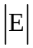 due to a point charge?
A. I and IV only
B. I, III, and IV only
C. I, II, and III only
D. I, II, III and IV

Use the following information to answer the next six questions.

The Photocopier

A typical copier has an aluminum drum that is coated with a thin layer of the semiconductor selenium. The drum is rotated through a container of toner. The toner consists of tiny charged plastic beads coated with carbon grains. The coated beads are attracted to the charged areas of the selenium layer on the drum but not to the areas where the charge has dispersed. A sheet of paper is then pressed against the drum and the coated beads are transferred to the paper. The paper is heated and the beads melt, attaching the carbon to the paper to form the image.

Numerical Response

- A photocopier requires 0.750 kilowatts when printing. To print 500 sheets on both sides at a rate of one side per second, the energy used by the photocopier, expressed in scientific notation, is b × 10^{-w} J. The value of b is ______.

(Record your three-digit answer in the numerical-response section on the answer sheet.)

Numerical Response

- When determining what to charge for printing on a photocopier, one of the “hidden" costs involved is the cost of electricity. After the copier is warmed up, it uses an average of 6.82 A while operating on a 110 V power supply. If the cost of electricity is 0.00200 cents per kJ, the cost to print 1020 copies at a rate of one copy per second would be ________ cents.

(Record your three-digit answer in the numerical-response section on the answer sheet.)

Use this additional information to answer the next four questions.

Photocopier
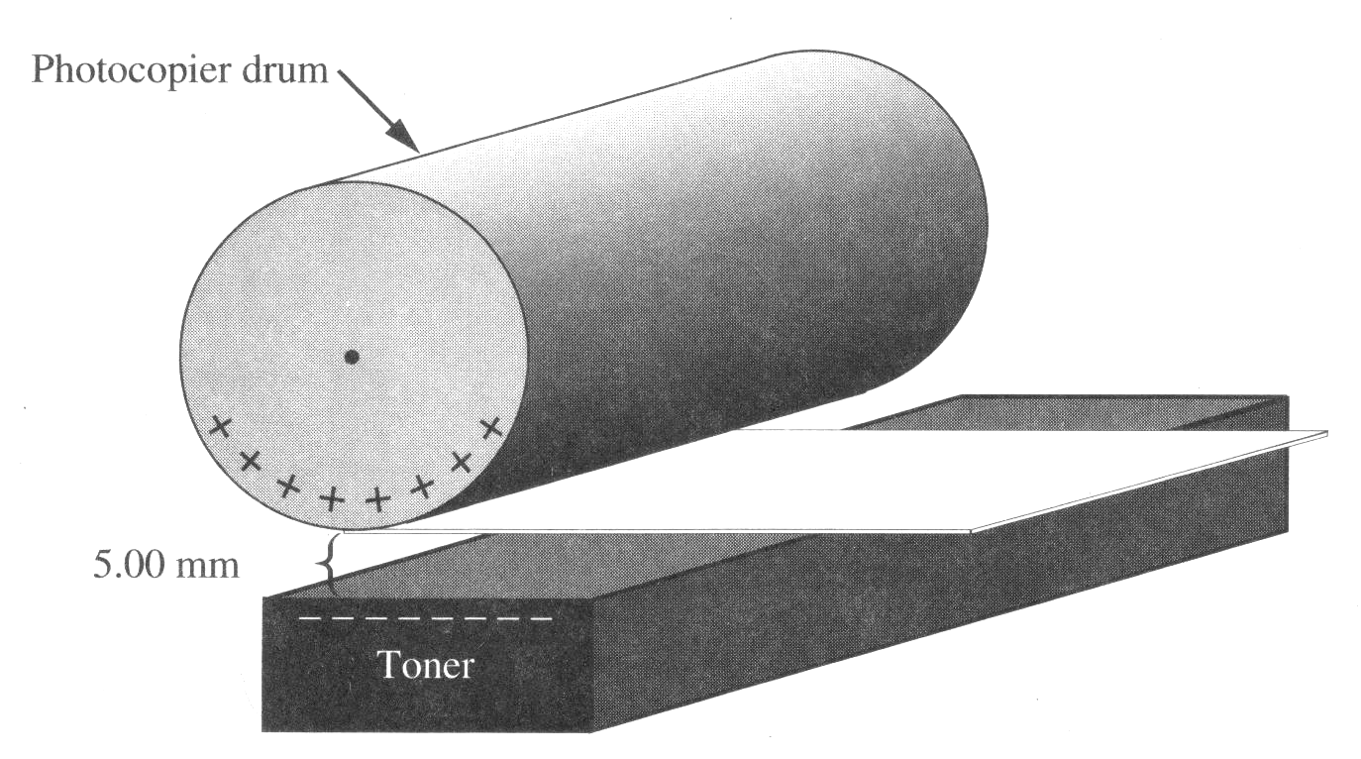
Assume that the beads of toner (dry ink) and letters on the drum act as point charges. The charge on each bead of toner is -6.40 x 10⁻¹⁶ C and the average charge on the part of the drum with the image of the letter copied is +7.10 x 10⁻¹³ C.

Numerical Response

- When the toner and the drum are separated by 5.00 mm, the force of attraction between the letter and the toner bead, expressed in scientific notation, is b × 10⁻¹³ N. The value of b is ________.

(Record your three-digit answer in the numerical-response section on the answer sheet.)

Use your answer from Numerical Response 3 to answer Numerical Response 4.

Numerical Response

- Each coated bead in the photocopier has an average mass of 1.92 x 10⁻¹⁵ kg. The acceleration of a bead toward the drum, expressed in scientific notation, is b × 10^{-w} m/s². Ignoring the presence of gravity, the value of b is _________.

(Record your three-digit answer in the numerical-response section on the answer sheet.)

- Suppose the charge on each bead of toner is reduced to -1.60 x 10⁻¹⁶ C. To have the same force of attraction between a letter and a toner bead as in Numerical Response 3, the distance separating the drum and the toner must be changed to
A. 1.30 mm
B. 2.50 mm
C. 1.00 mm
D. 2.00 mm

- If the drum is positive and the toner is negative, the direction of the electric field at a point halfway between the drum and the toner is
A. in the same direction of the drum rotation
B. in the opposite direction of the drum rotation
C. from the drum to the toner
D. from the toner to the drum

- Which graph shows the relationship between current I and resistance R for resistors that obey Ohm's law and are connected to a constant potential difference?
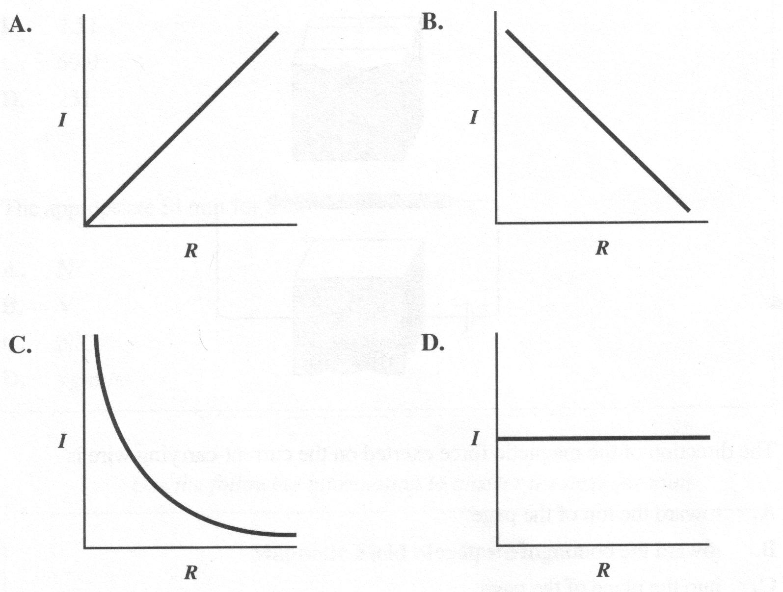

Use the following information to answer the next question.

A Current in an External Magnetic Field
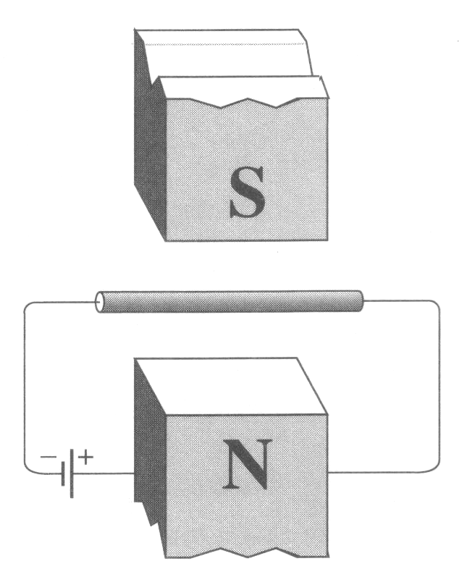

- The direction of the magnetic force exerted on the current-carrying wire is
A. toward the top of the page
B. toward the bottom of the page
C. into the plane of the page
D. out of the plane of the page

Use the following information to answer the next two questions.

S = B v l

A wire of length l (with a speed v) passes perpendicularly through an external magnetic field B.

- When the magnetic field strength is 0.235 T, the speed of the wire is 10.7 m/s and the length of the wire is 27.8 cm. The numerical value of S in SI base units is
A. 0.699
B. 2.51
C. 69.9
D. 251

- The appropriate Sl unit for S is
A. N
B. V
C. N/C
D. kg·m/s
___________________________

Use the following information to answer the next question.

Magnetic Field of a Bar Magnet

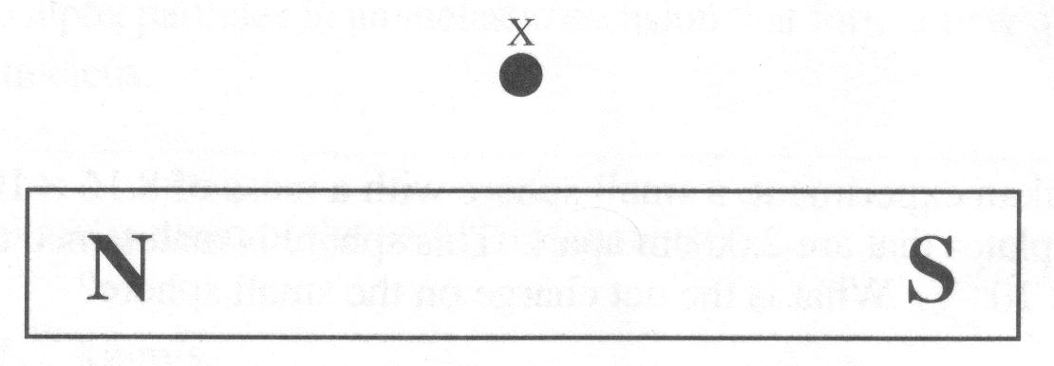

- The direction of the magnetic field at point X is toward the
A. bottom of the page
B. right of the page
C. left of the page
D. top of the page

Use the following information to answer the next question.

An alpha particle and an electron traveling at the same speed enter perpendicularly into a uniform magnetic field.

- Which of the following statements concerning the forces on the particles is true?
A. The force on the alpha particle is greater because it carries the higher charge.
B. The force on the alpha particle is greater because its mass is greater.
C. The force on the electron is greater because its mass is smaller.
D. The force on the particles is equal.

Numerical Response

- A certain charged particle moves in a path of radius 25.0 cm, in a uniform magnetic field. If the speed of the particle is doubled and the magnetic field strength is quadrupled, the new radius is _________ cm.

(Record your three-digit answer in the numerical-response section on the answer sheet.)

- In a Millikan experiment, a small sphere with a mass of 8.16 x 10⁻¹⁶ kg, is suspended between plates that are 2.00 cm apart. This sphere is maintained at a potential difference of 1.00 x 10² V. What is the net charge on the small sphere?
A. 1.60 x 10⁻¹⁹ C
B. 1.60 x 10⁻¹⁸ C
C. 8.00 x 10⁻¹⁷ C
D. 4.00 x 10⁻¹² C

Use the following information to answer the next three questions.

Linear Accelerator

The following is a simplification of what takes place when charged particles are accelerated and collisions take place. To accelerate alpha particles, charged parallel plates may be used. The magnitude of the electric field between two charged parallel plates at a fixed distance d apart can be calculated for different distances x from the positive plate.
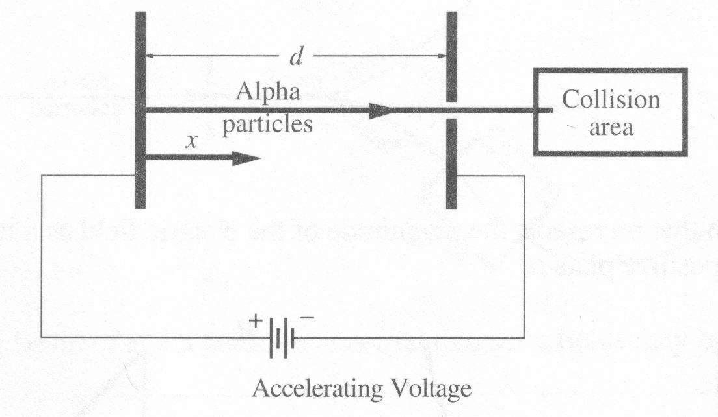

In the collision area, the incoming alpha particles moving at 8.07 x 10⁶ m/s collide with other alpha particles that are at rest. Assume that each collision involves two alpha particles in an inelastic collision that form a new 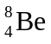 (beryllium) nucleus.

- What is the final momentum of the new nucleus?
A. 1.07 x 10⁻¹⁹ kg·m/s
B. 5.37 x 10⁻²⁰ kg·m/s
C. 2.68 x 10⁻²⁰ kg·m/s
D. 1.35 x 10⁻²⁰ kg·m/s

Use your answer from Multiple Choice 13 to answer Numerical Response 6.

Numerical Response

- Some initial kinetic energy is carried over to the kinetic energy of the new particle . This energy is not available for creating new particles or for putting the nucleus into an excited state. The kinetic energy of the nucleus, expressed in scientific notation, is b × 10^{-w} J. The value of b is ________.

(Record your three-digit answer in the numerical-response section on the answer sheet.)

- The graph that represents the magnitude of the electric field as a function of the distance x from the positive plate is
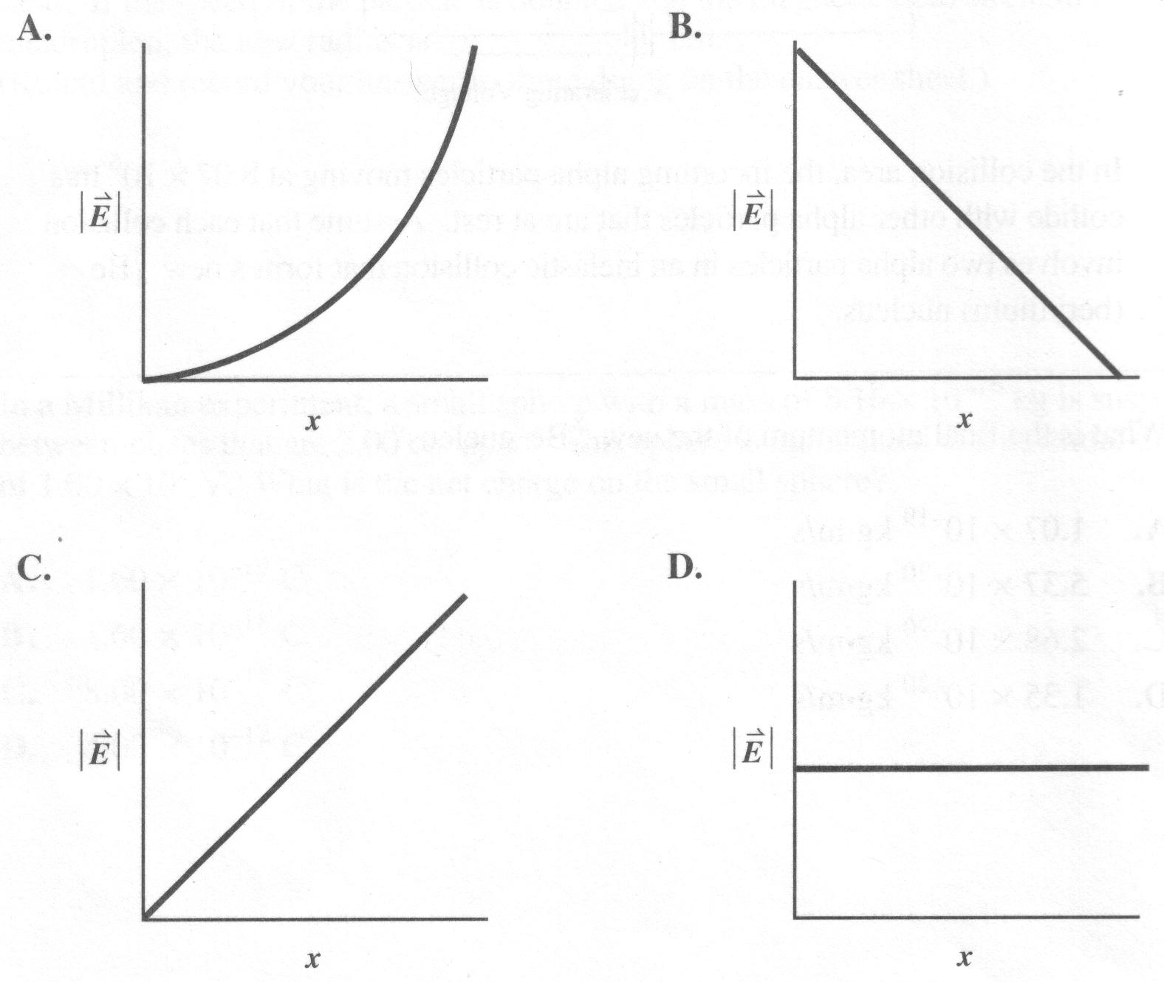

Use the following information to answer the next two questions.

Zero Momentum Collisions

In order to have the maximum initial kinetic energy available for the creation of new particles, physicists design equipment to create head-on collisions with particles having the same magnitude of momentum. Thus the total momentum of the colliding particles is zero.
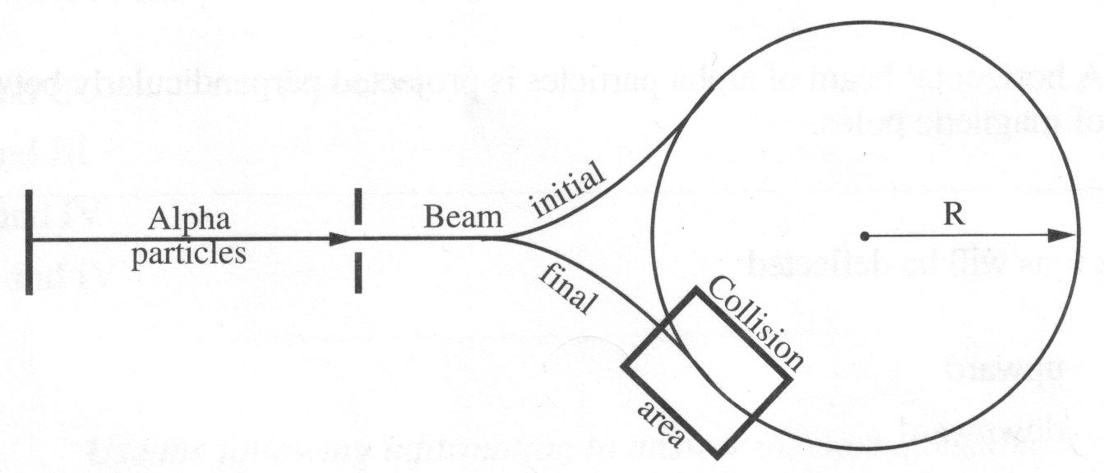
To bend the beam of alpha particles, external magnetic fields may be used.

- To make an alpha particle that is moving at a speed of 8.07 x 10⁶ m/s follow a path of radius 10.0 m, how strong must the magnetic field be?
A. 5.37 x 10⁻²⁰ T
B. 1.68 x 10⁻² T
C. 3.35 x 10⁻² T
D. 8.07 x 10⁵ T

- The magnitude of the force exerted on a charged particle by a magnetic field depends on the
A. sign of the charge
B. mass of the particle
C. velocity of the particle
D. perpendicular depth of the field

Use the following information to answer the next question.

Alpha Particles in Magnetic Fields
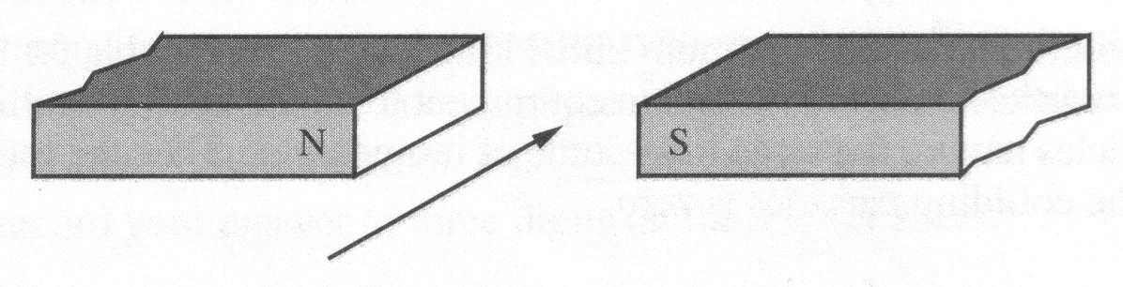

A horizontal beam of alpha particles is projected perpendicularly between a pair of magnetic poles.

- The ions will be deflected
A. upward
B. downward
C. toward the north pole
D. toward the south pole

Numerical Response

- A transformer has 60 turns on the primary coil and 300 turns on the secondary coil. It is used to supply a motor that requires a current of 2.54 A. The current in the primary coil is ________ A.

(Record your three-digit answer in the numerical-response section on the answer sheet.)

Use the following information to answer the next question.

I Oscillating magnet
II Accelerating proton
III Steady electric current
IV Stationary electron

- The phenomena that produce an electromagnetic wave are
A. I and II
B. I and III
C. II and IV
D. III and IV

Use the following information to answer the next question.

The electric field strength near a large transformer was measured over a period of time. The results are graphed below.

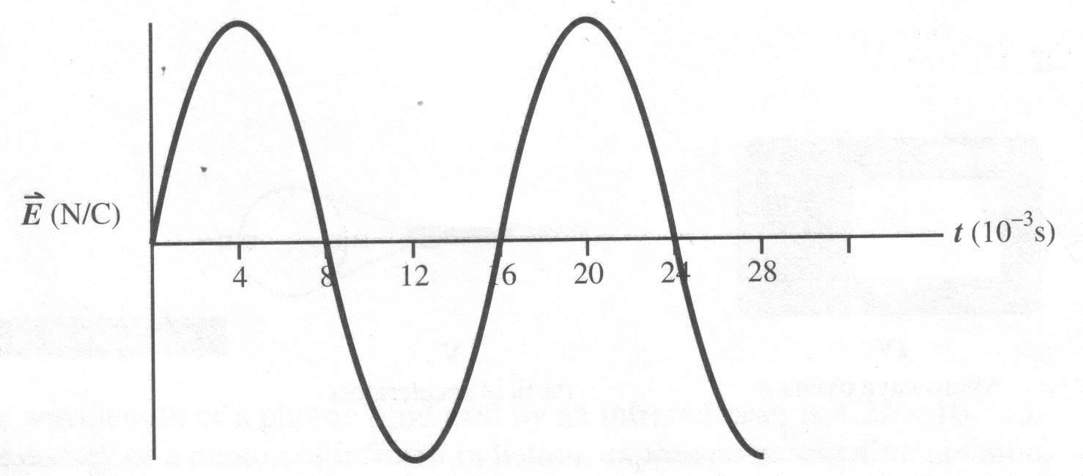

Numerical Response

- The wavelength of the source, expressed in scientific notation, is b × 10^{w} m. The value of b is ________.

(Record your three-digit answer in the numerical-response section on the answer sheet.)

- Which of the following regions of the electromagnetic spectrum do not overlap?
A. X-ray and ultraviolet
B. Radar and microwave
C. Microwave and infrared
D. Gamma rays and ultraviolet

Use the following information to answer the next four questions.

Researchers have developed a reliable blue laser that could revolutionize optical data storage. It is now possible to focus blue light on a smaller spot so that data can be stored five times more densely than with the more conventional infrared laser. Blue light oscillates with a period of 1.53 x 10⁻¹⁵ s.

- Which quality of blue light makes it possible to store data five times more densely?
A. Blue light is in the visible region of the electromagnetic spectrum.
B. Blue light has a shorter wavelength.
C. Blue light has a lower frequency.
D. Blue light refracts less.

Numerical Response

- The wavelength of blue light, expressed in scientific notation, is b × 10^{-w} m. The value of b is __________.

(Record your three-digit answer in the numerical-response section on the answer sheet.)

Numerical Response

- The wavelength of a photon produced by an infrared laser is 4.23 x 10⁻⁵ m. The energy of a photon of infrared radiation, expressed in scientific notation, is b × 10^{-w} eV. The value of b is __________.

(Record your three-digit answer in the numerical-response section on the answer sheet.)

- The momentum of a photon of blue light is directly proportional to its
A. wavelength
B. frequency
C. rest mass
D. velocity

Use the following information to answer the next three questions.

A common application of the quantum theory in technology is the development of automatic door openers and burglar alarms, which are operated by electric eyes. An electromagnetic beam shines across a door opening onto a photovoltaic cell. This causes electrons to be emitted, creating a current that flows in a circuit. When the beam is broken, the current stops and a mechanism is triggered to open a door or sound an alarm.
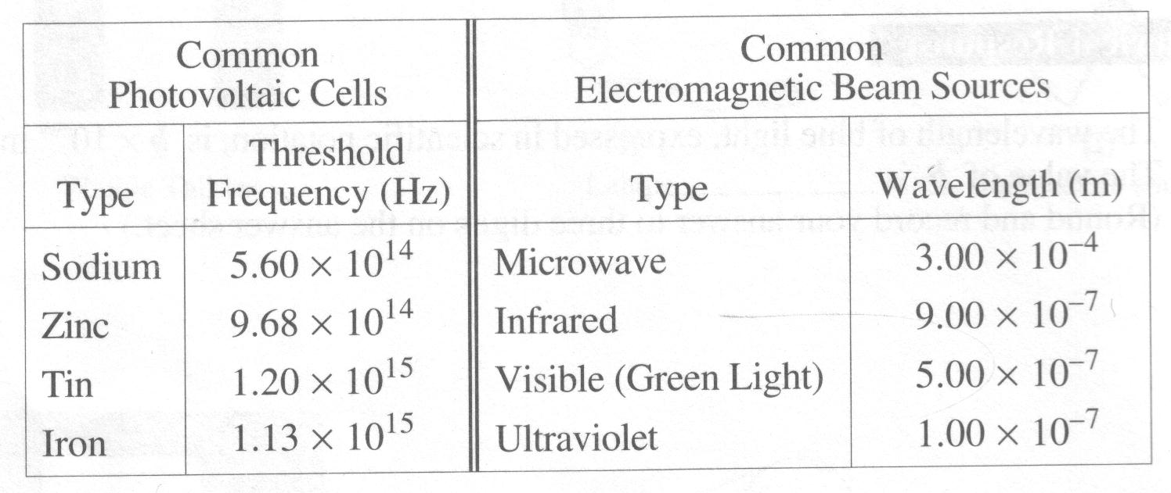

- Which of the given electromagnetic beam sources would be able to activate all of the given photovoltaic cells listed?
A. Ultraviolet
B. Microwave
C. Ultraviolet and Visible
D. Microwave and Infrared

- Which combination of electromagnetic beam sources and photovoltaic cells would emit electrons with the greatest kinetic energy?
A. Microwave beam with a sodium photovoltaic cell
B. Ultraviolet beam with a sodium photovoltaic cell
C. Microwave beam with an iron photovoltaic cell
D. Ultraviolet beam with an iron photovoltaic cell

- A newly designed burglar alarm uses a photocell with a threshold frequency of 8.0 x 10¹⁴ Hz. When a light with a frequency of 1.05 x 10¹⁵ Hz is directed on the cell, what is the kinetic energy of the released photoelectrons?
A. 4.4 eV
B. 3.3 eV
C. 1.7 eV
D. 1.0 eV
__________________________

Use the following diagram to answer the next five questions.

X-ray Tube

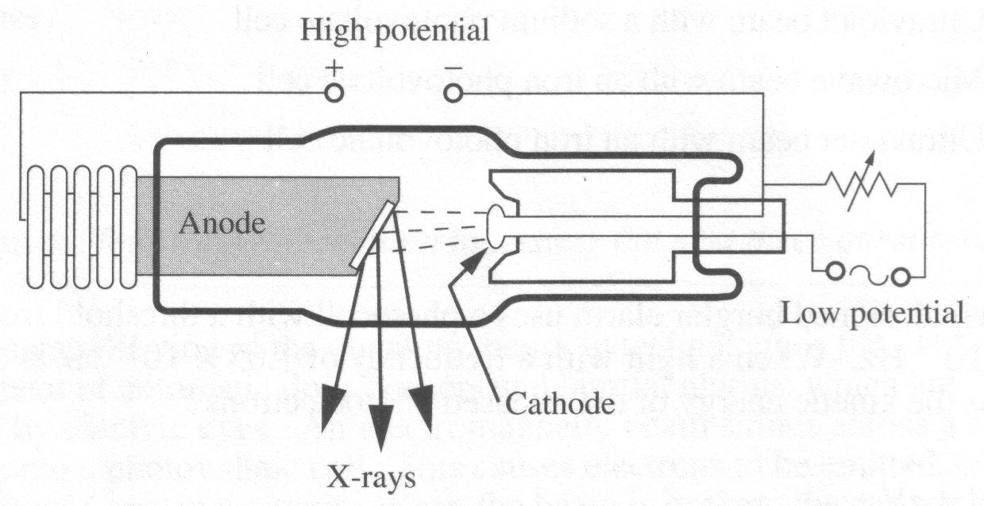

- The reason for enclosing the anode and cathode of an X-ray tube in a vacuum is that the
A. X-rays travel faster in a vacuum
B. air would allow too much heat to escape
C. vacuum is required to focus the X-rays
D. electron beam has difficulty traveling through air

- If the potential difference between the anode and the cathode is increased, the X-rays produced will have
A. shorter wavelengths and greater penetrating power
B. longer wavelengths and greater penetrating power
C. shorter wavelengths and less penetrating power
D. longer wavelengths and less penetrating power

- While keeping the voltage constant and varying the cur-rent between the cathode and the anode, an X-ray technician controls the
A. penetrating power of the X-rays
B. wavelength of the X-rays
C. frequency of the X-rays
D. intensity of the X-rays

- The energy absorbed by living matter exposed to X-ray radiation can be quite devastating. The greatest amount of energy absorbed would occur when the
A. time of exposure is long and the rate of exposure is low
B. time of exposure is long and the rate of exposure is high
C. time of exposure is short and the rate of exposure is low
D. time of exposure is short and the rate of exposure is high

- X-rays are sometimes used to kill cancer cells in patients. However, the procedure must be used with great caution because
A. X-rays also destroy healthy cells in the patient
B. X-rays are produced by high energy electrons
C. hospital workers cannot be protected from X-rays
D. electrical and magnetic fields cannot be used to control X-rays

Use the following information to answer the next three questions.

In a Franck-Hertz experiment, free electrons are- emitted from the cathode of a low pressure tube containing mercury vapour. The free electrons strike the mercury vapour atoms in the tube. The accelerating voltage on the electrons leaving the cathode is gradually increased.

Below is a graph showing the relationship between the collected current transmitted through the mercury vapour and the accelerating voltage. An energy level diagram for mercury is also shown.

Collected Current vs. Accelerating Voltage

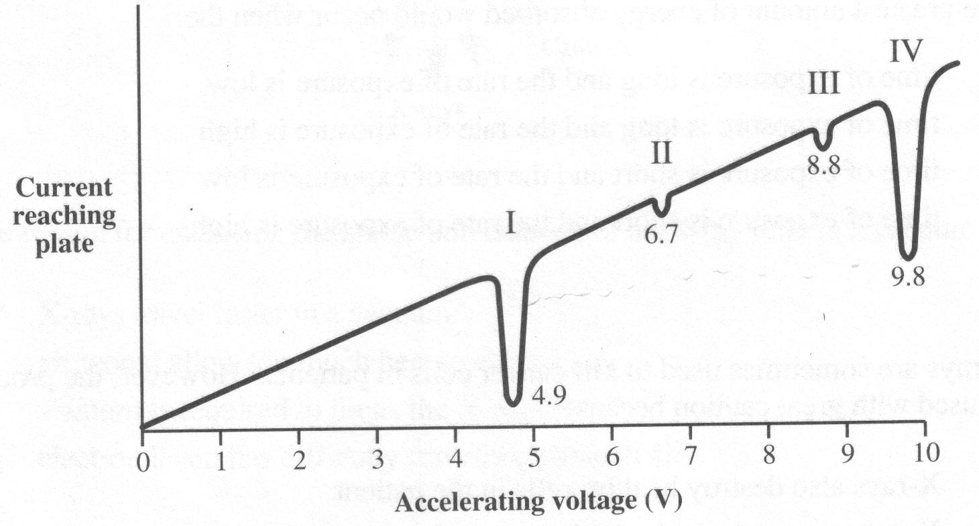

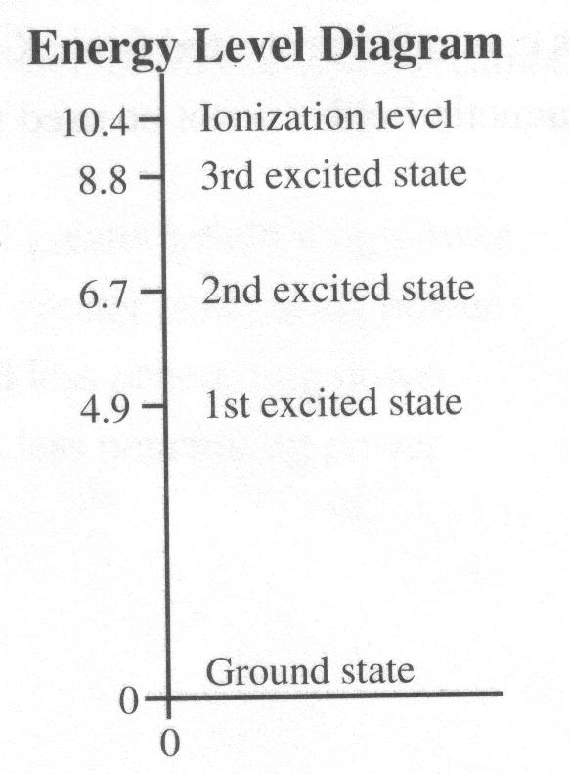

- When the accelerating voltage on an electron is 3.0 V, the electron will
A. separately strike and excite two mercury atoms to the first excited state
B. strike a mercury atom and excite it to the second excited state
C. strike a mercury atom and excite it to the first excited state
D. pass directly to the anode without exciting any mercury atoms

- Which region on the graph represents the effect on an electron that excites a single mercury atom to the third excited state?
A. I
B. II
C. III
D. IV

- Region IV on the graph represents electrons that
A. struck two mercury atoms separately and excited each atom to the first excited state
B. struck several mercury atoms and excited them to the second excited state
C. struck several mercury atoms and excited them to the first excited state
D. passed directly to the anode without exciting any mercury atoms

___________________________

- From the spectrum given off by a young star, several extremely bright lines stand out from all the rest. The wavelength of one of the intense bright lines is 656.21 nm. This wavelength represents an energy change in the atom of
A. 3.03 x 10¹⁹ J
B. 3.29 x 10¹⁸ J
C. 3.29 x 10⁻¹⁸ J
D. 3.03 x 10⁻¹⁹ J

- An electron in the hydrogen atom changes from the n = 5 state to the n = 2 state. According to the Bohr model, the electron moves toward the nucleus a distance of
A. 3r₁
B. 5r₁
C. 21r₁
D. 25r₁

Use the following information to answer the next three questions.

In the decay of 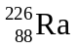, two groups of alpha particle energies are observed.
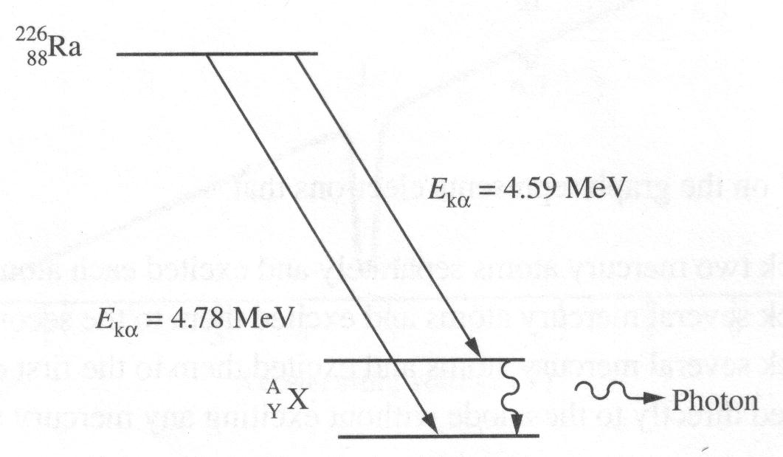

The difference in kinetic energy between the alpha particles can be accounted for by the release of a photon.

Numerical Response

- The wavelength of the emitted photon, expressed in scientific notation, is b × 10^{-w} m. The value of b is _________.

(Record your three-digit answer in the numerical-response section on the answer sheet.)

Numerical Response

- The half-life of is 1.62 x 10³ y. If 2.04 mg of radium were present, the mass of radium remaining after 4.86 x 10³ y would be, expressed in scientific notation, b × 10^{-w} mg. The value of b is _________.

(Record your three-digit answer in the numerical-response section on the answer sheet.)

Use the additional information to answer the next question.

Statement I Radium always has an atomic number of 88.
Statement II The radium nucleus always contains 88 neutrons.

- Which of the following responses correctly describes the two statements?
A. Both statements are true, and one statement can be explained by the other.
B. Both statements are true, but neither statement can be used to explain the other.
C. Statement I is true, and statement II is false.
D. Statement I is false, and statement II is false.
___________________________

- Radioactive materials are frequently used as tracers to monitor systems in the human body. To test the function of a patient's kidney, a small volume of solution containing a radioactive isotope with an activity of 3600 disintegrations per minute is injected into the bloodstream. After two hours, the activity of 20 cm 3 of blood is three disintegrations per minute. If the half-life of the isotope is one hour, the estimated volume of blood inside the patient is
A. 7500 cm³
B. 6000 cm³
C. 4500 cm³
D. 3000 cm³

